CUSTOMER CHURN RESEARCH PAPER

1. Abstract
Customer churn is a major challenge in the banking industry, directly affecting profitability and long-term growth. This study analyses customer behaviour using a structured banking dataset to identify patterns associated with churn. The research focuses on demographic, financial, and engagement-related attributes such as age, balance, credit score, geography, and customer activity.
The study reveals that churn is strongly influenced by customer inactivity, geographical differences, and financial risk indicators. High-balance customers and inactive users show significantly higher churn probability. The findings provide actionable insights for building retention strategies, improving customer engagement, and reducing revenue loss.

2. Introduction
Customer churn refers to the situation when a customer stops using a company’s services. In the banking sector, churn occurs when customers close their accounts or stop actively using banking services.
Churn is critically important because acquiring new customers is significantly more expensive than retaining existing ones. Even a small increase in retention can lead to a substantial rise in profitability.
In banking, churn leads to:
- Loss of revenue from inactive accounts
- Reduced customer lifetime value
- Increased marketing and acquisition costs
Understanding churn behaviour helps banks design better retention strategies and improve customer satisfaction.

📊 3. Dataset Overview
Dataset Description
The dataset contains customer-level banking information used to predict churn behaviour
Original Features
- Customer Id
- Surname
- Credit Score
- Geography
- Gender
- Age
- Tenure
- Balance
- Num Of Products
- Has Cr Card
- Is Active Member
- Estimated Salary
- Exited

🔹 Dataset Composition
👉 Customer Churn Distribution
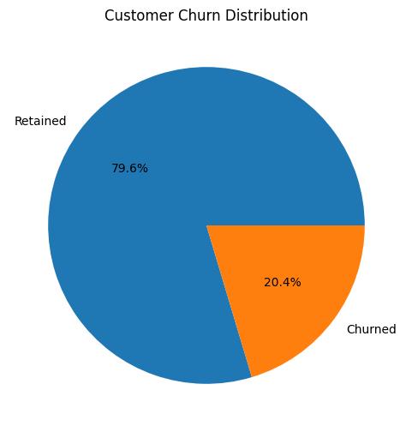
Interpretation
- The churn distribution chart provides an overview of customer retention performance and highlights the proportion of customers who exited versus those who remained with the bank.

🧹 5. Data Cleaning & Preparation
The dataset underwent multiple preprocessing steps to ensure accuracy and consistency:
- Removed irrelevant columns such as Surname
- Handled categorical variables using encoding techniques
- Converted categorical features into numerical format
- Created feature bands for better interpretation:
  - Age groups
  - Credit score categories
  - Balance segments
- Checked for missing values and data inconsistencies
These steps ensured the dataset was ready for machine learning and visualization.

Correlation Analysis
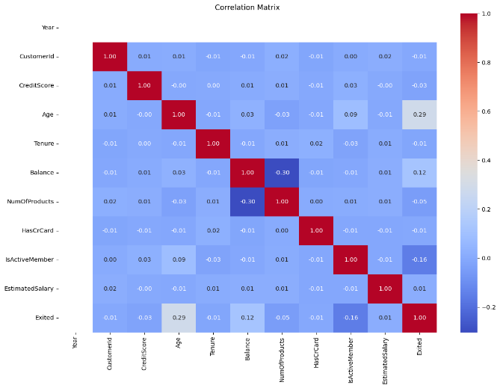
The correlation matrix was generated to examine relationships among numerical variables. Most variables showed weak to moderate correlations, indicating limited multicollinearity. Age, Balance, Credit Score, and the engineered features demonstrated meaningful relationships with customer churn and were therefore retained for predictive modelling.

6. Geography Analysis
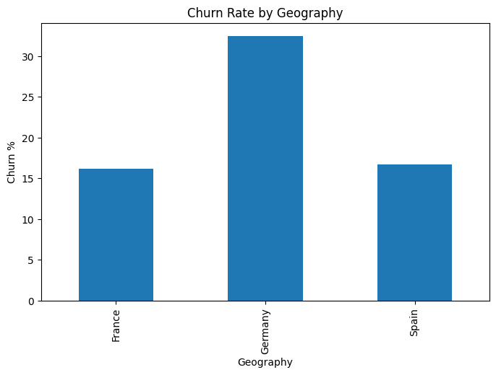
Geography plays an important role in customer churn behaviour. The dataset shows variation in churn rates across different countries.
Key observation:
- Some regions show significantly higher churn compared to others
- Regional economic conditions and banking preferences may influence this behaviour
This analysis helps banks focus on region-specific retention strategies.

👥 7. Demographic Analysis
🔹 Age vs Churn
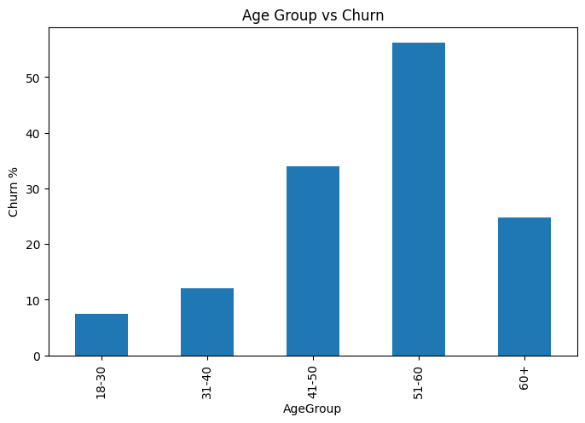
Age emerged as one of the strongest churn predictors.
Model interpretation indicates:
- Churn probability remains relatively stable among younger customers.
- Churn risk rises significantly after age 45.
- Peak churn probability occurs around ages 55–60.
This suggests older customers may require specialized engagement programs.

🔹 Gender Analysis
Male vs Female churn comparison
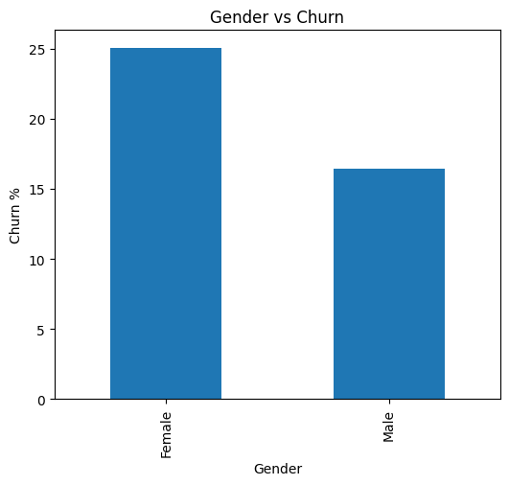
Gender-based analysis shows differences in churn behaviour between male and female customers.
- Slight variations exist in churn distribution
- Behaviour is influenced more by financial activity than gender alone

💰 8. Financial Behaviour Analysis
🔹 Balance vs Churn
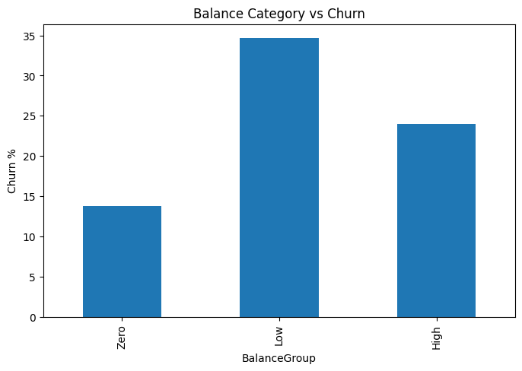
Customers with different account balances show varying churn tendencies:
- Zero balance customers show higher churn likelihood
- High balance customers are more valuable but still at risk
- Low balance customers show moderate churn behaviour

🔹 Credit Score vs Churn
Customers with different account balances show varying churn tendencies:
- Zero balance customers show higher churn likelihood
- High balance customers are more valuable but still at risk
- Low balance customers show moderate churn behaviour

⏳ 9. Tenure Analysis
🔹 Tenure vs Churn
Customer tenure directly affects retention:
- New customers (0–2 years) show highest churn
- Mid-tenure customers are relatively stable
- Long-term customers are most loyal
This highlights the importance of early engagement strategies.

💎 10. High-Value Customer Analysis
🔹 High Value Churn
High-value customers are those with significant account balances or financial activity.
- Churning high-value customers causes major revenue loss
- Even small churn rates in this segment are critical.

🔹Salary vs Balance Relationship
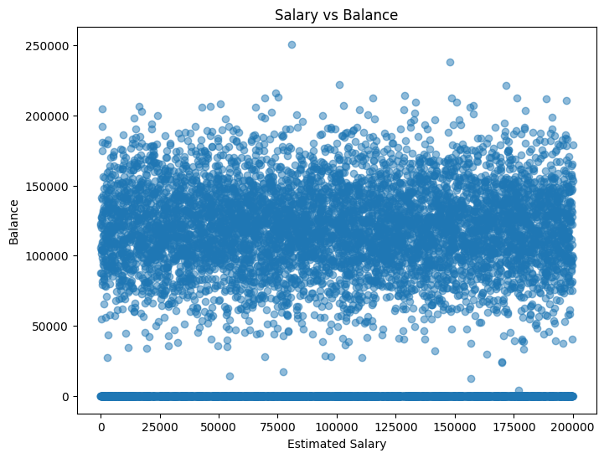
This relationship shows financial behaviour patterns:
- No strong direct correlation between salary and balance
- Some high-income customers maintain low balances
- Financial habits vary significantly across customers

📊 11. Engagement Analysis
🔹 Active vs Inactive Customers
Customer engagement is one of the strongest churn indicators:
- Inactive members show much higher churn rates
- Active customers are more likely to stay
- Engagement is a key retention factor

📌 12. Machine Learning Model Evaluation
Model | Accuracy | ROC-AUC
Logistic Regression | 78.20% | 0.732
Decision Tree | 79.10% | 0.682
Random Forest | 86.10% | 0.849
Gradient Boosting | 87.20% | 0.865

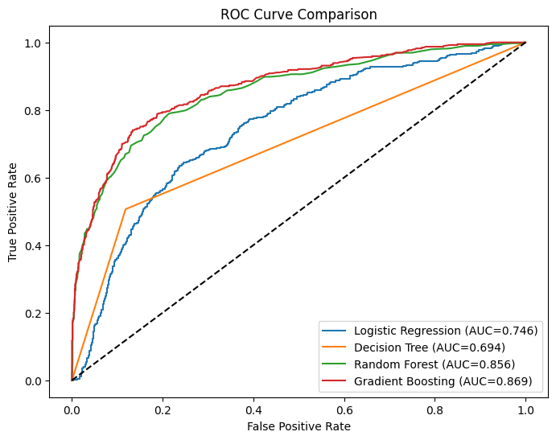

📈 13. Key Findings
- Gradient Boosting achieved the best predictive performance with 87.2% accuracy and 86.5% ROC-AUC.
- Product Density was the most important feature influencing customer churn.
- Age emerged as the second most significant predictor.
- Credit Score and Balance strongly influenced retention behaviour.
- Feature engineering substantially improved model performance.
- Customer engagement indicators contributed meaningful predictive value.
- Product ownership patterns are strongly associated with churn probability.

🧠 14. Discussion
The findings demonstrate that customer churn is influenced by a complex interaction of demographic, financial, and behavioural factors.
Traditional predictors such as Age, Credit Score, and Balance remain important. However, engineered variables including Product Density and Balance-Salary Ratio contributed additional predictive power by capturing customer behaviour more effectively.
The superior performance of Gradient Boosting indicates that non-linear relationships exist within customer churn behaviour and can be effectively model using ensemble learning techniques.
These insights can support more personalized customer retention strategies and proactive risk management initiatives.

🎯 15. Recommendations
Based on the findings, the following actions are recommended:
- Customer Retention Programs
- Product Cross-Selling
- High-Value Customer Monitoring
- Regional Strategies
- Predictive Monitoring

🏁 16. Conclusion
This study successfully developed a machine learning framework for predicting customer churn in the banking sector.
Through extensive preprocessing, feature engineering, and model evaluation, the project identified key factors driving customer attrition. Gradient Boosting emerged as the best-performing model, demonstrating strong predictive capability.
The findings highlight the importance of customer engagement, product ownership, age, creditworthiness, and financial behaviour in determining churn risk. By leveraging these insights, banks can improve retention strategies, reduce revenue loss, and enhance long-term customer relationships.
The proposed predictive framework can serve as a valuable decision-support tool for customer relationship management and strategic planning.

